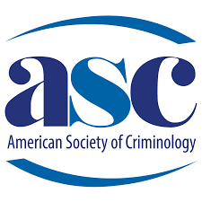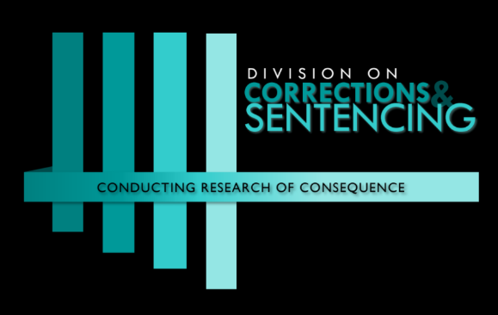

Sponsorship Form for Contributions to

ASC’s Division on Corrections & Sentencing

To make an organizational sponsorship contribution to the American Society of Criminology’s Division on Correction & Sentencing, please email the division a copy of your completed form to the DCS Chair, Shelley Johnson at slistwan@uncc.edu. The American Society of Criminology main office will send you an invoice for payment. Your contribution will be utilized for the Division’s breakfast at the Annual Conference, awards for students and special scholars, and/or our annual review publication. Acknowledgement of your generosity will be featured in the list of DCS sponsors at the breakfast, in our newsletter, and on our website. The Division thanks you for your support!
Your Organization: _____________________________________________________________________
Contact Name: _________________________________________________________________________
Phone Number of Contact: ________________________________________________________________
Email of Contact: _______________________________________________________________________
Address of Organization: _________________________________________________________________
City, State, Zip Code: ____________________________________________________________________

Level of Sponsorship:
☐ $2,500 – Platinum Level
☐ $1,000 – Gold Level
☐ $500 – Silver Level
☐ $250 – Bronze Level
☐ Other Amount: ____________

